Week 3 Internship Report

NumPy and Pandas for Data Manipulation
Name: Neha Beldar
Internship: Python Data Analysis Internship
Week: Week 3
Task: NumPy and Pandas for Data Manipulation

1. Introduction
In Week 3 of the internship, the focus was on learning and applying NumPy and Pandas, two powerful Python libraries used for data analysis and data manipulation.
NumPy is mainly used for numerical computations and array operations, while Pandas is used for handling structured data such as tables and datasets.
During this task, a dataset containing product sales information was analyzed. The project involved data cleaning, statistical analysis, and category-wise aggregation of sales data.

2. Objectives of the Task
The main objectives of this task were:
- To understand NumPy arrays and mathematical operations
- To learn Pandas DataFrames and data manipulation
- To perform data cleaning
- To analyze data using grouping and aggregation techniques
- To gain practical experience in data analysis using Python

3. Tools and Technologies Used
The following tools and technologies were used to complete this task:
- Python
- NumPy
- Pandas
- Visual Studio Code (VS Code)
- 4. Dataset Description
The dataset used in this project is sales_data.csv.
It contains information about product sales including:
Column | Description
Product | Name of the product
Category | Category of the product
Sales | Sales amount
The dataset intentionally includes:
- Missing values
- Duplicate records
These issues were handled during the data cleaning process.

5. Implementation Steps
The following steps were performed in the Python script:

Step 1: Import Libraries
NumPy and Pandas libraries were imported to perform data manipulation and analysis.

Step 2: Load Dataset
The dataset was loaded using the Pandas function:
pd.read_csv()

Step 3: Data Cleaning
Data cleaning was performed by:
- Removing missing values
- Removing duplicate records
This ensures that the dataset is clean and ready for analysis.

Step 4: NumPy Operations
The Sales column was converted into a NumPy array.
Using NumPy, the following statistical calculations were performed:
- Average sales
- Maximum sales
- Minimum sales
- Total sales

Step 5: Data Analysis with Pandas
Pandas was used to perform data aggregation and grouping.
Two analyses were performed:
- Category-wise sales analysis
- Product-wise sales summary
This helped to understand how sales are distributed across different categories and products.

6. Output of the Program
The program successfully displayed:
- Original dataset
- Cleaned dataset
- Sales statistics
- Category-wise sales analysis
- Product-wise sales summary

Example Output:
Average Sales: 20571
Maximum Sales: 55000
Minimum Sales: 5000
Total Sales: 144000

7. Key Concepts Learned
Through this task, the following concepts were learned:

NumPy Concepts
- NumPy arrays
- Mathematical operations
- Statistical calculations (mean, max, min, sum)

Pandas Concepts
- DataFrames
- Reading CSV files
- Data cleaning
- Handling missing values
- Removing duplicates
- GroupBy operations
- Data aggregation

8. Screenshots of Program Output
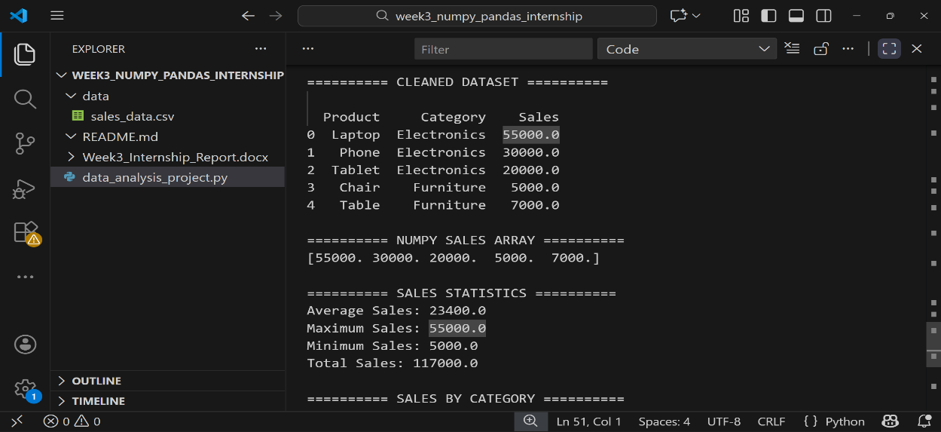

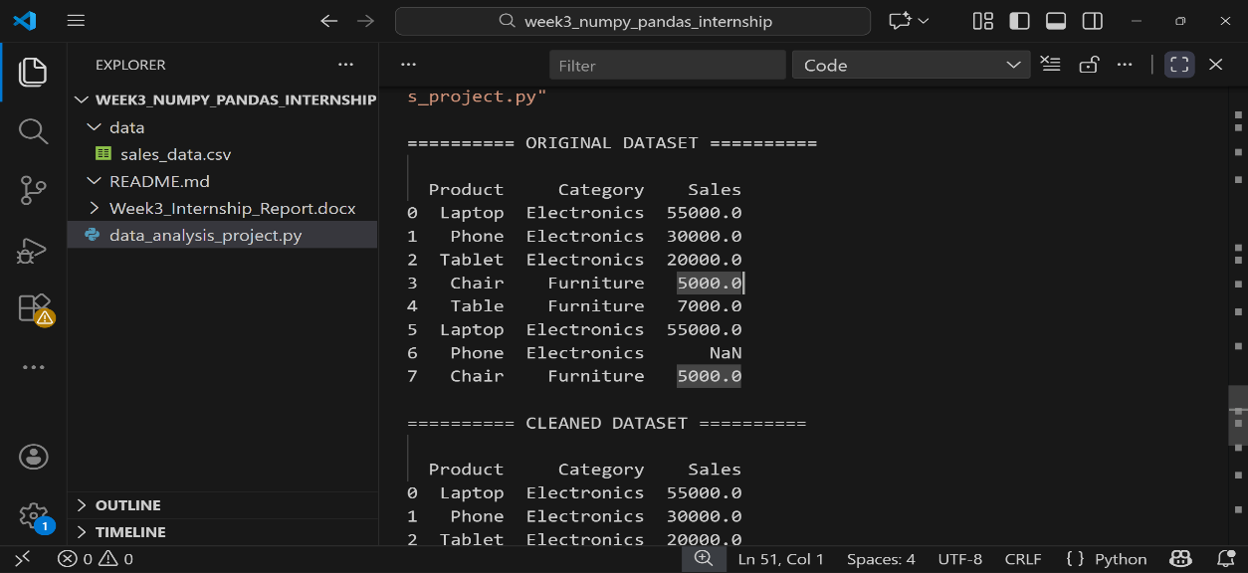
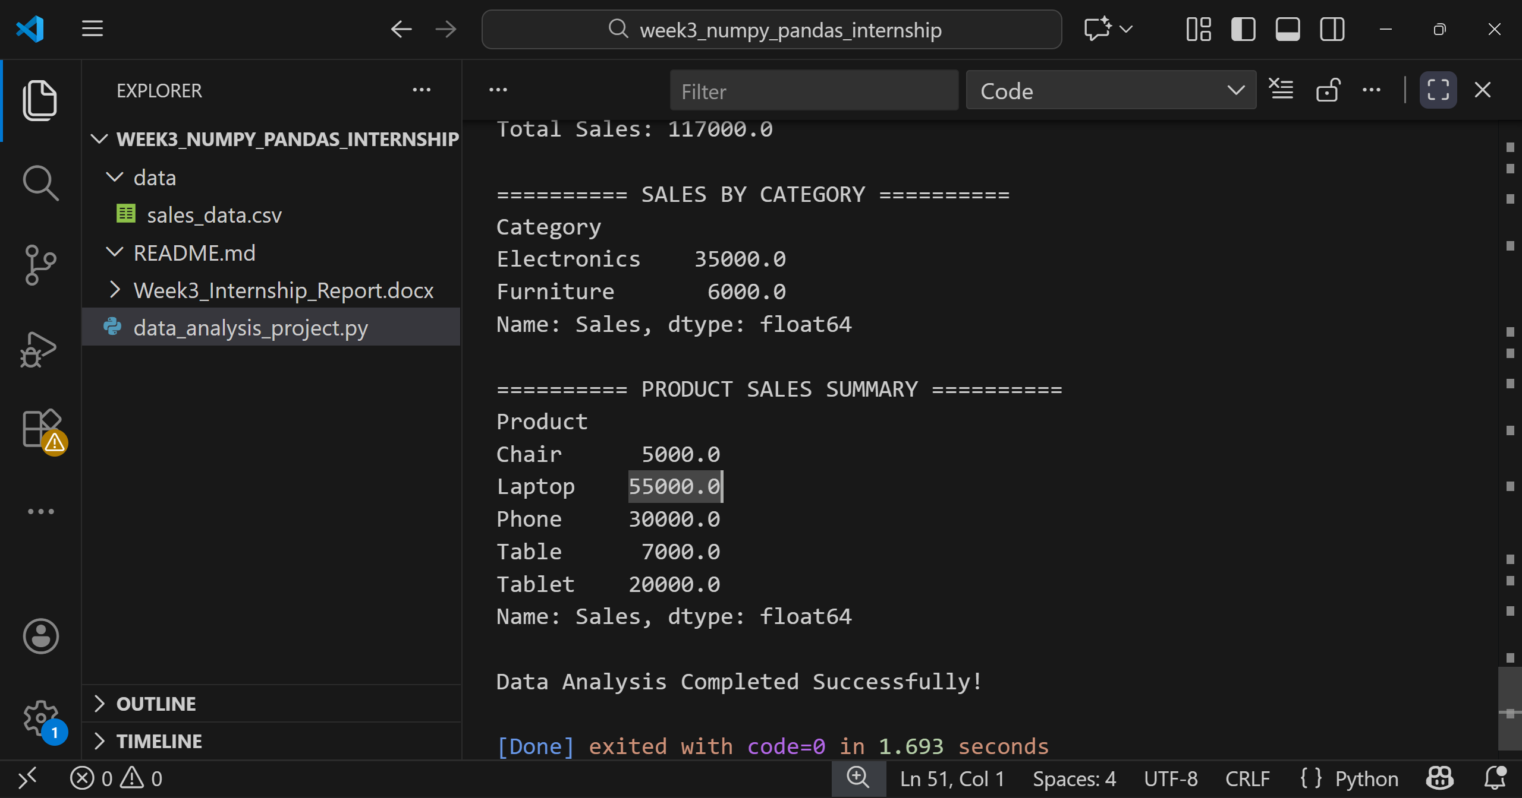

9. Conclusion
This task provided practical experience in data manipulation and analysis using NumPy and Pandas.
The project demonstrated how Python can be used to clean datasets, perform statistical analysis, and extract meaningful insights from data.
These skills are essential for data analysis and data science applications.

10. Project Files
The project contains the following files:
- data_analysis_project.py – Python script for data analysis
- sales_data.csv – Dataset used in the project
- README.md – Project documentation
- Week3_Internship_Report.docx – Summary report

